**Steps Involved in Machine Learning Process**

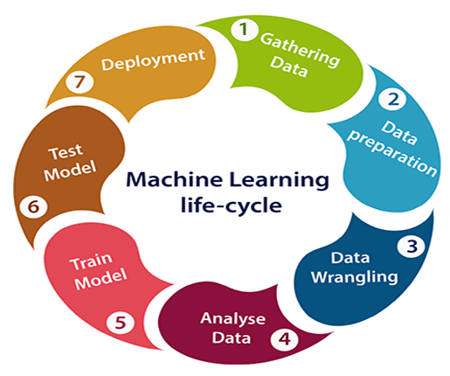

Reference [1]

1. Problem Definition: Clearly articulate the problem you want to solve, including the goals, objectives, and success criteria. Understand the business context and how solving this problem will add value.
2. Data collection: Collect relevant information from a variety of sources, making sure it is reliable, comprehensive, and representative. The data should be cleaned, prepped, and transformed to make it acceptable for analysis.
3. Data Pre-processing or Data Wrangling: Clean the data by handling missing values, removing outliers, and transforming the data into a suitable format. This step ensures that the data is ready for model training.
4. Data Splitting: Divide the dataset into training, validation, and testing sets. The validation set is used to adjust hyper parameters and avoid over fitting, the training set is used to train the model, and the testing set is used to assess the performance of the finished model.
5. Model Selection: Choose an appropriate machine learning algorithm or model architecture based on the problem type and characteristics of the data. This decision can impact the model's performance.
6. Model Training: Train the selected model using the training data. The model learns patterns and relationships from the data to make predictions or decisions. Optimize the hyper parameters of the model to achieve the best performance on the validation set. This involves adjusting parameters that are not learned during training, such as learning rates, regularization strength, etc.
7. Model Evaluation: Assess the model's performance on the testing set to ensure that it generalizes well to unseen data. Common evaluation metrics include accuracy, precision, recall, F1-score, etc.
8. Model Deployment: Making the model accessible to users is referred to as deployment. Deployment is an ongoing process. Several methods may be used, including hosting the model on a cloud service, deploying the model locally, and including the model in a mobile application.8. Well-known dataset repository sites
9. Monitoring and Maintenance: Monitor the deployed model's performance and update it as needed. As new data becomes available, retrain the model to keep it up-to-date.

References

<https://www.javatpoint.com/machine-learning-life-cycle>

<https://www.ibm.com/topics/machine-learning>

<https://en.wikipedia.org/wiki/Machine_learning>